1.1P: Preparing for OOP – Answer Sheet

1. Explain the following terminal instructions:
   1. cd: Change Directory
   2. ls: Lists all the files in the current directory
   3. pwd: prints the working directory (aka current file path)
2. Consider the following kinds of information, and suggest the most appropriate data type to store or represent each:

|  |  |
| --- | --- |
| Information | Suggested Data Type |
| A person’s name | String |
| A person’s age in years | Int (could be float) |
| A phone number | Int |
| A temperature in Celsius | Float |
| The average age of a group of people | Float |
| Whether a person has eaten lunch | Boolean |

1. Aside from the examples already provided in question 2, come up with an example of information that could be stored as:

|  |  |
| --- | --- |
| Data type | Suggested Information |
| String | Car manufacturer |
| Integer | Student ID |
| Float | Velocity |
| Boolean | Has student passed unit? |

1. Fill out the following table, evaluating the value of each expression and identifying the data type the value is most likely to be:

|  |  |  |  |
| --- | --- | --- | --- |
| Expression | Given | Value | Datatype |
| 6 |  | 6 | Integer |
| True |  | True | Boolean |
| A | a = 2.5 | 2.5 | Float |
| 1 + 2 * 3 |  | 7 | Integer |
| a and false | a = true | False | Boolean |
| a or false | a = false | False | Boolean |
| a + b | a = 1, b = 2 | 3 | Integer |
| 2 * a | a = 3 | 6 | Integer |
| a * 2 + b | a = 2.5, b = 2 | 7 | Float |
| a + 2 * b | a = 2.5, b = 2 | 6.5 | Float |
| (a + b) * c | a = 1, b = 1, c = 5 | 10 | Integer |
| “Fred” + “ Smith” |  | Fred Smith | String |
| a + “ Smith” | a = “Wilma” | Wilma Smith | String |

1. Using an example, explain the difference between **declaring** and **initialising** a variable.

The difference between the two is When a variable is declared it becomes known to the compiler and memory is allocated, a variable does not become initialized until there’s a value associated with it.

1. Explain the term **parameter**. Write some code that demonstrates a simple of use of a parameter. You should show a procedure or function that uses a parameter, and how you would call that procedure or function.

Parameters are variables which are passed into a function and allow functions to access data they otherwise wouldn’t be able to.

1. Using an example, describe the term **scope**.

The scope of a variable refers to where in the code that variable can be accessed. In Ruby, for example, variables can have global scope,

$$globalVariable1

Variables can also have a local scope in which case they must be passed through as parameters in order to be access by other functions.

1. In any procedural language you like, write a function called Average, which accepts an array of integers and returns the average of those integers. Do not use any libraries for calculating the average. You must demonstrate appropriate use of parameters, returning and assigning values, and use of a loop. Note — just write the function at this point, we’ll *use* it in the next task. You shouldn’t have a complete program or even code that outputs anything yet at the end of this question.

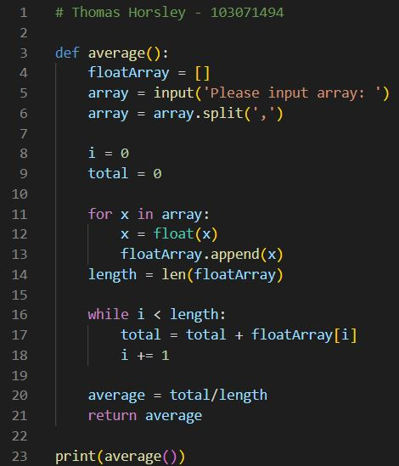

1. In the same language, write the code you would need to call that function and print out the result.

See 10

1. Text

   Description automatically generatedText

   Description automatically generatedText

   Description automatically generatedTo the code from 9, add code to print the message “Double digits” if the average is above or equal to 10. Otherwise, print the message “Single digits”. Provide a screenshot of your program running.